***Public Health Awareness***

***PROJECT OBJECTIVE:***

***Analzying data :***

*Analyzing public health awareness campaign data,such as measuring audience*

*reach,awareness levels,and campaign impact*

***Data collection:***

*Identify the sources and methods for collecting campaign data,including*

*engagement metrics audience demographics and awareness surveys.*

***Visualization strategy:***

*Plan how to visualize the insights using ibm cognos to create informative*

*dashboards and reports.*

***Code integration:***

*Decide which aspects of the analysis can be enhanced using code such as data*

*cleaning transformation and statistical analysis.*

***Awareness for public:***

*Health professionals can initiate, lead and guide communications awareness in the HiAP context so as to ensure that health is a key priority in policies of social, economic, development and environment sectors. An effective public health awareness involves grouping messages and activities around a Single Overarching Communications Objective (SOCO), that identifies the change that you want to achieve, against actionable and measurable targets. An effective public health awareness has a well-defined target audience, which is positioned to act upon the messages that you convey. An effective public health campaign has key messages that conveys solid public health facts but appeals to the heart as well as the mind.Problem*

***statement:***

*Purpose of public health awareness Addressing social and environmental health risks/determinants such as air pollution, housing risks,water and waste risks, occupational risks, and chemical hazards, generally cannot be addressed only at the individual and health care provider level. These require policy action by non-health sector actors. As health in all policies “ambassadors” we need to be able to communicate convincingly about risks – and solutions - to a range of other audiences, from policymakers in sectors such as transport, energy and finance, to the general public.*

***Guidelines to society:***

*We need to feel comfortable “stepping outside” of the paradigm of patient treatment and behaviour change – to tackle a much wider world of policy choices.*

*And that includes leadership in communications campaigns that build greater community awareness of health impacts, health-based discussion of policy options, which lead to concrete decisions by governments and active involvement of civil society.*

***Fundamentals of awareness:***

*To that aim, knowing the fundamentals of good communications skills and tactics, and how to apply those in real-life issues that we face, is essential, and will make you more effective in your HiAP aims and interactions. Lecture sections are numbered to correspondent with the PowerPoint Slide deck.These principles are drawn from the wider WHO communications package. Effective*

*Communications and applied specifically to the HiAP setting. However, it is highly worthwhile to*

*review the entire WHO model, which is referenced in your recommended readings.*

***Characteristics of public health awareness :***

*Effective campaigns require you to define clearly what*

*is your communications goal or aim first of all, something we call the Single Overarching*

*Communications Outcome (SOCO) 5 But developing a SOCO also requires you to know your audience, and what are their priorities and concerns, and then shaping your message to relate to those issues, and eventually trigger a reaction. Effective campaigns also are not just about building clear sharp messages, however important. While the message is one building block, it is not the only one. Building a campaign requires you to consider the range of tactics and tools. that are most suitable to your audience to deliver those messages, as well as to engage them*

*interactively in action.*

***Source code*** *:*

*Import pandas as pd*

*Import numpy as np*

*Import seaborn as sns*

*Import matplotlib.pyplot as plt*

*Data = pd.read_csv(‘/kaggle/input/mental-health-in-tech-survey/survey.csv’)*

*Data.head()*

*# I am using Pandas for data manipulation.*

*# Matplotlib, Seaborn and hvPlot for Data Visualization*

In [2]:

import pandas as pd

import numpy as np

import matplotlib.pyplot as plt

import seaborn as sns

import os

In [3]:

*# I will then create the file path and file name, load my dataset, create a dataframe and assign it to the name "df"*

In [4]:

os.listdir("/kaggle/input/")

Out[4]:

['mental-health-in-tech-survey']

In [5]:

df = pd.read_csv("/kaggle/input/mental-health-in-tech-survey/survey.csv")

In [6]:

*# To see the shape of the dataframe:*

df.shape

Out[6]:

(1259, 27)

Data Cleaning: Missing Values

In [7]:

*# We seek for information about our data using .info()*

*# It will help us see both the missing values & data types for each attribute*

*# The index, columns, and number of missing values*

df.info()

<class 'pandas.core.frame.DataFrame'>

RangeIndex: 1259 entries, 0 to 1258

Data columns (total 27 columns):

# Column Non-Null Count Dtype

--- ------ -------------- -----

0 Timestamp 1259 non-null object

1 Age 1259 non-null int64

2 Gender 1259 non-null object

3 Country 1259 non-null object

4 state 744 non-null object

5 self_employed 1241 non-null object

6 family_history 1259 non-null object

7 treatment 1259 non-null object

8 work_interfere 995 non-null object

9 no_employees 1259 non-null object

10 remote_work 1259 non-null object

11 tech_company 1259 non-null object

12 benefits 1259 non-null object

13 care_options 1259 non-null object

14 wellness_program 1259 non-null object

15 seek_help 1259 non-null object

16 anonymity 1259 non-null object

17 leave 1259 non-null object

18 mental_health_consequence 1259 non-null object

19 phys_health_consequence 1259 non-null object

20 coworkers 1259 non-null object

21 supervisor 1259 non-null object

22 mental_health_interview 1259 non-null object

23 phys_health_interview 1259 non-null object

24 mental_vs_physical 1259 non-null object

25 obs_consequence 1259 non-null object

26 comments 164 non-null object

dtypes: int64(1), object(26)

memory usage: 265.7+ KB

In [8]:

*# I can see the exact number of missing values there is using the isna().sum()*

In [9]:

df.isna().sum()

Out[9]:

Timestamp 0

Age 0

Gender 0

Country 0

state 515

self_employed 18

family_history 0

treatment 0

work_interfere 264

no_employees 0

remote_work 0

tech_company 0

benefits 0

care_options 0

wellness_program 0

seek_help 0

anonymity 0

leave 0

mental_health_consequence 0

phys_health_consequence 0

coworkers 0

supervisor 0

mental_health_interview 0

phys_health_interview 0

mental_vs_physical 0

obs_consequence 0

comments 1095

dtype: int64

In [10]:

*# From the above analyses, we see that;*

*# "state",*

*# "self_employed" and*

*# "work_interfere"*

*# "comments"*

*# all have missing values*

In [11]:

*# In the future, I will drop "state" and "comments' columns because we won't be needing them*

*# Our analysis will be done at "country" level, since our dataset covers different countries*

*# So I will be filling up the missing values for just "self_employed" and "work_interfere" columns*

In [12]:

*# I want to see the percentage missing values in "self_employed" and "work_interfere" columns*

*# I will use the round() function to round them to 2 decimal places*

self_employed_percent = (df["self_employed"].isnull().sum()/len(df["self_employed"]))*100

work_interfere_percent = (df["work_interfere"].isnull().sum()/len(df["work_interfere"]))*100

print(f"The percentage of missing values in self_employed column is **{**round(self_employed_percent, 2)**}**%")

print(f"The percentage of missing values in work_interfere column is **{**round(work_interfere_percent, 2)**}**%")

The percentage of missing values in self_employed column is 1.43%

The percentage of missing values in work_interfere column is 20.97%

In [13]:

*# Because I have approx. 80% of both, I will fill up both columns with the mode for each.*

In [14]:

df["self_employed"] = df["self_employed"].fillna(df["self_employed"].mode()[0])

df["work_interfere"] = df["work_interfere"].fillna(df["work_interfere"].mode()[0])

In [15]:

*# I can now take a peek at our dataframe to see how it looks like, using the .head() method*

In [16]:

df.head()

Out[16]:

|  | Timestamp | Age | Gender | Country | state | self_employed | family_history | treatment | work_interfere | no_employees | ... | leave | mental_health_consequence | phys_health_consequence | coworkers | supervisor | mental_health_interview | phys_health_interview | mental_vs_physical | obs_consequence | comments |
| --- | --- | --- | --- | --- | --- | --- | --- | --- | --- | --- | --- | --- | --- | --- | --- | --- | --- | --- | --- | --- | --- |
| 0 | 2014-08-27 11:29:31 | 37 | Female | United States | IL | No | No | Yes | Often | 6-25 | ... | Somewhat easy | No | No | Some of them | Yes | No | Maybe | Yes | No | NaN |
| 1 | 2014-08-27 11:29:37 | 44 | M | United States | IN | No | No | No | Rarely | More than 1000 | ... | Don't know | Maybe | No | No | No | No | No | Don't know | No | NaN |
| 2 | 2014-08-27 11:29:44 | 32 | Male | Canada | NaN | No | No | No | Rarely | 6-25 | ... | Somewhat difficult | No | No | Yes | Yes | Yes | Yes | No | No | NaN |
| 3 | 2014-08-27 11:29:46 | 31 | Male | United Kingdom | NaN | No | Yes | Yes | Often | 26-100 | ... | Somewhat difficult | Yes | Yes | Some of them | No | Maybe | Maybe | No | Yes | NaN |
| 4 | 2014-08-27 11:30:22 | 31 | Male | United States | TX | No | No | No | Never | 100-500 | ... | Don't know | No | No | Some of them | Yes | Yes | Yes | Don't know | No | NaN |

5 rows × 27 columns

In [17]:

*# Final step is to drop the "state" and "comments" columns*

*# And then, I will confirm that all missing values have been fixed*

In [18]:

df.drop(["state", "comments"], axis=1, inplace=True)

In [19]:

df.isna().sum()

Out[19]:

Timestamp 0

Age 0

Gender 0

Country 0

self_employed 0

family_history 0

treatment 0

work_interfere 0

no_employees 0

remote_work 0

tech_company 0

benefits 0

care_options 0

wellness_program 0

seek_help 0

anonymity 0

leave 0

mental_health_consequence 0

phys_health_consequence 0

coworkers 0

supervisor 0

mental_health_interview 0

phys_health_interview 0

mental_vs_physical 0

obs_consequence 0

dtype: int64

In [20]:

*# Our dataframe is now free of any missing values.*

Univariate Analyses

In [21]:

*# First, let's see all our columns*

In [22]:

df.columns

Out[22]:

Index(['Timestamp', 'Age', 'Gender', 'Country', 'self_employed',

'family_history', 'treatment', 'work_interfere', 'no_employees',

'remote_work', 'tech_company', 'benefits', 'care_options',

'wellness_program', 'seek_help', 'anonymity', 'leave',

'mental_health_consequence', 'phys_health_consequence', 'coworkers',

'supervisor', 'mental_health_interview', 'phys_health_interview',

'mental_vs_physical', 'obs_consequence'],

dtype='object')

In [23]:

*# First, I will look at some of the interesting attributes and analyse them*

Attribute 1: Country

In [24]:

plt.figure(figsize=(17,5))

ax = sns.countplot(x='Country', data=df)

ax.set_xticklabels(

ax.get_xticklabels(),

rotation=45,

horizontalalignment='right'

)

None *# So it won't show the label objects*

*# Then we also display the values for each bar above it;*

for p **in** ax.patches:

ax.annotate(p.get_height(), (p.get_x()+0.25, p.get_height()+0.01), ha='center')

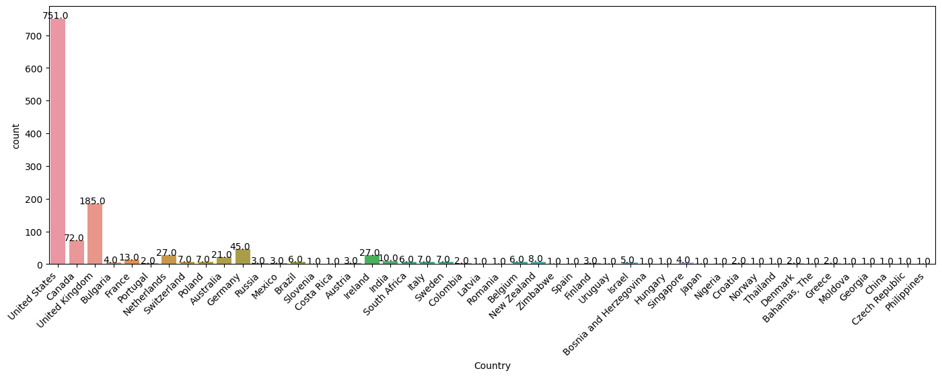

In [25]:

*# We clearly see above that the countries with the highest number of mental health issues in Tech are;*

*# United States*

*# United Kingdom*

*# Canada*

In [26]:

*# But why is this so?*

*# I can proceed to look at other factors like "Age", "remote_work", "family_history", "no_employees", etc*

Attribute 2: Age

In [27]:

*# To analyze this, it's best I group them into categories*

*# To help me get a good enough group size, I will see the min, max, median and mean of the distribution for Age*

In [28]:

min_age = df["Age"].min()

max_age = df["Age"].max()

mean_age = df["Age"].mean()

median_age = df["Age"].median()

print(f"Min: **{**min_age**}**, **\n**Max: **{**max_age**}**, **\n**Mean: **{**mean_age**}**, **\n**Median: **{**median_age**}**")

Min: -1726,

Max: 99999999999,

Mean: 79428148.31135821,

Median: 31.0

In [29]:

*# We see from above, that even though all Age collumns are filled, some of the values are invalid*

In [30]:

*# By my own personal preference, I will replace all invalid values by the median, 31.*

*# I chose this because I believe for people in tech today, 31 seems appropariate to use.*

*# I will also exclude those above 80, and treat them as invalid.*

*# Then I will see if there are other outliers worth looking at.*

In [31]:

df["Age"].unique()

Out[31]:

array([ 37, 44, 32, 31, 33,

35, 39, 42, 23, 29,

36, 27, 46, 41, 34,

30, 40, 38, 50, 24,

18, 28, 26, 22, 19,

25, 45, 21, -29, 43,

56, 60, 54, 329, 55,

99999999999, 48, 20, 57, 58,

47, 62, 51, 65, 49,

-1726, 5, 53, 61, 8,

11, -1, 72])

In [32]:

*# I would like to see the number of values with negative or above 80.*

negative_age = (df["Age"]<0).sum()

over_age = (df["Age"]>80).sum()

print(f"Number of negative age entries: **{**negative_age**}\n**Number of overage: **{**over_age**}**")

Number of negative age entries: 3

Number of overage: 2

In [33]:

*# Setting them to the median age*

df.loc[df.Age<0, ["Age"]] = df["Age"].median()

df.loc[df.Age>80, ["Age"]] = df["Age"].median()

In [34]:

df["Age"].unique()

Out[34]:

array([37, 44, 32, 31, 33, 35, 39, 42, 23, 29, 36, 27, 46, 41, 34, 30, 40,

38, 50, 24, 18, 28, 26, 22, 19, 25, 45, 21, 43, 56, 60, 54, 55, 48,

20, 57, 58, 47, 62, 51, 65, 49, 5, 53, 61, 8, 11, 72])

In [35]:

*# We have outliers of 5years, 8years*

*# With our domain knowledge, we can confidently go further to treat these as invalid.*

*# Only 18 and above is accepted to be a legal tech employee.*

*# I will replace them with the median.*

In [36]:

df.loc[df.Age<18, ["Age"]] = df["Age"].median()

In [37]:

df["Age"].hist()

Out[37]:

<Axes: >

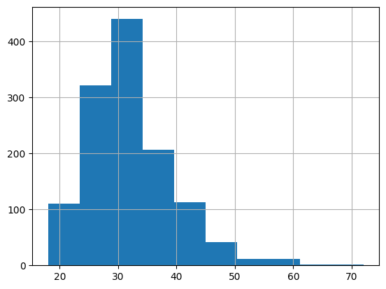

In [38]:

sns.boxplot(x=df["Age"])

Out[38]:

<Axes: xlabel='Age'>

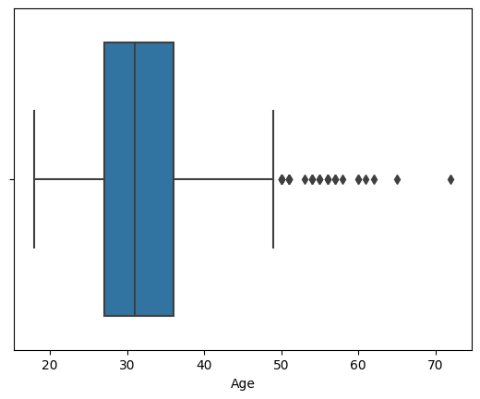

In [39]:

*# Outliers: Age above 50*

*# These can be men and women who entered tech in the 80's*

New Results for Mean. Also calculate for S.Deviation & Variance

In [40]:

import statistics

variance_age = df["Age"].var()

standard_dev_age = statistics.stdev(df["Age"])

print(f"Mean: **{**round(mean_age, 2)**}**"

f"**\n**Variance: **{**round(variance_age, 2)**}**"

f"**\n**Standard Deviation: **{**round(standard_dev_age, 2)**}**")

Mean: 79428148.31

Variance: 52.79

Standard Deviation: 7.27

Five (5) Other Attributes: No. of Employees, Family History, Remote Work, Self-Employed & Tech Company

In [41]:

plt.figure(figsize=(7,4))

ax = sns.countplot(x='no_employees', data=df)

ax.set_xticklabels(ax.get_xticklabels(),

rotation=45,

horizontalalignment='right')

*# Then we also display the values for each bar above it;*

for p **in** ax.patches:

ax.annotate(p.get_height(), (p.get_x()+0.25, p.get_height()+0.01), ha='center')

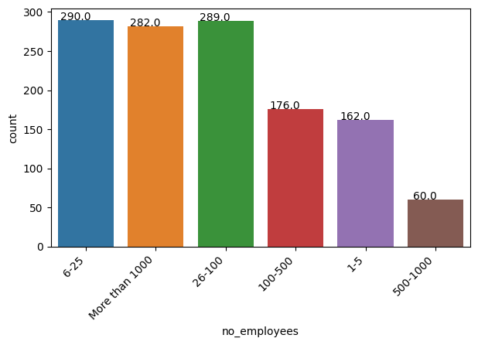

In [42]:

*# This doesn't help us much, because number of employees isn't directly proportional with cases of mental health.*

*# In fact, there are identical mental health issues with employees working in companies with staff strengths of*

*# 6 - 25*

*# 25 - 100*

*# More than 1000*

In [43]:

plt.figure(figsize=(5,5))

ax = sns.countplot(x='family_history', data=df)

ax.set_xticklabels(ax.get_xticklabels(),

horizontalalignment='right')

for p **in** ax.patches:

ax.annotate(p.get_height(), (p.get_x()+0.25, p.get_height()+0.01), ha='center')

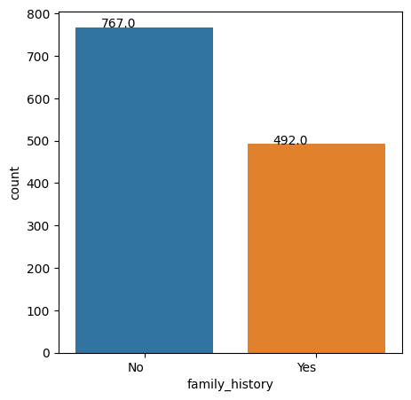

In [44]:

plt.figure(figsize=(5,5))

ax = sns.countplot(x='remote_work', data=df)

ax.set_xticklabels(ax.get_xticklabels(),

horizontalalignment='right')

for p **in** ax.patches:

ax.annotate(p.get_height(), (p.get_x()+0.25, p.get_height()+0.01), ha='center')

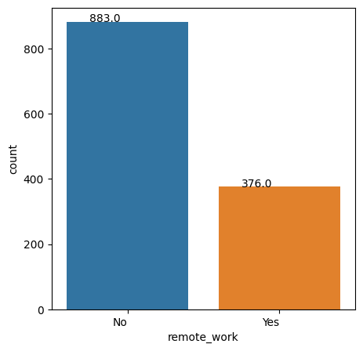

In [45]:

plt.figure(figsize=(5,5))

ax = sns.countplot(x='self_employed', data=df)

ax.set_xticklabels(ax.get_xticklabels(),

horizontalalignment='right')

for p **in** ax.patches:

ax.annotate(p.get_height(), (p.get_x()+0.25, p.get_height()+0.01), ha='center')

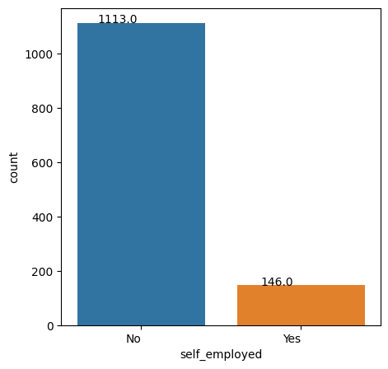

In [46]:

plt.figure(figsize=(5,5))

ax = sns.countplot(x='tech_company', data=df)

ax.set_xticklabels(ax.get_xticklabels(),

horizontalalignment='right')

for p **in** ax.patches:

ax.annotate(p.get_height(), (p.get_x()+0.25, p.get_height()+0.01), ha='center')

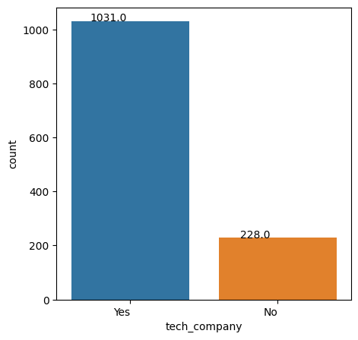

Attribute 8: Time

In [47]:

df["Timestamp"].head()

Out[47]:

0 2014-08-27 11:29:31

1 2014-08-27 11:29:37

2 2014-08-27 11:29:44

3 2014-08-27 11:29:46

4 2014-08-27 11:30:22

Name: Timestamp, dtype: object

In [48]:

*# For me to work with just the Years, excluding the Time, Months and Days, I will do the following;*

df_year = pd.to_datetime(df["Timestamp"]).dt.year

df_year.head()

Out[48]:

0 2014

1 2014

2 2014

3 2014

4 2014

Name: Timestamp, dtype: int32

In [49]:

*# I will add this year column to my dataframe and plot the histogram*

df["Year"] = df_year

plt.figure(figsize=(5,5))

ax = sns.countplot(x='Year', data=df)

ax.set_xticklabels(ax.get_xticklabels(),

horizontalalignment='right')

for p **in** ax.patches:

ax.annotate(p.get_height(), (p.get_x()+0.25, p.get_height()+0.01), ha='center')

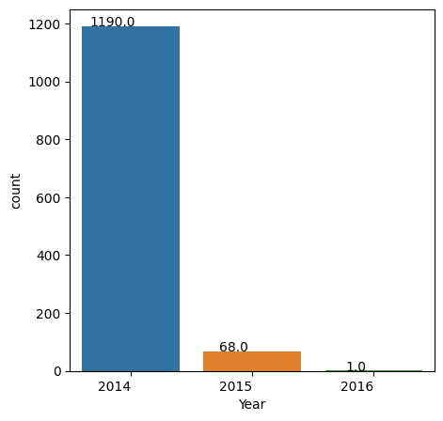

In [50]:

*# There has to be a reason why only 68 cases of mental health amongst employees was recorded in 2015.*

*# For 2016, we assume it's because the data stopped in Feb 2016.*

Conclusion of Univariate Analysis

In [51]:

*# Nevertheless, we can still draw some very useful insights from the above analyses;*

*# 1.) USA, UK and Canada accounts for the most cases*

*# 2.) Mental Health issues affect more of individuals who are;*

*# Employees*

*# Aged between 25-40*

*# Working in the office, and not remote, and*

*# Working in Tech companies*

Bivariate & Multivariate Analyses

In [52]:

*# I will analyse further to see relationships between attributes and see if there are similarities.*

In [53]:

df.describe()

Out[53]:

|  | Age | Year |
| --- | --- | --- |
| count | 1259.000000 | 1259.00000 |
| mean | 32.069897 | 2014.05560 |
| std | 7.265565 | 0.23268 |
| min | 18.000000 | 2014.00000 |
| 25% | 27.000000 | 2014.00000 |
| 50% | 31.000000 | 2014.00000 |
| 75% | 36.000000 | 2014.00000 |
| max | 72.000000 | 2016.00000 |

In [54]:

*# We see above that only the "Age" column contains numerical values*

*# Therefore, in order to proceed I will have to convert the categorical variables into numerical*

Data Manipulation: Changing from Categorical to Numerical

In [55]:

*# I will assign No: 0 and Yes: 1 where applicable*

*# Then for "Don't Know", "Maybe" I will assign 2*

*# Finally, I will create a new column comprising of the numerical values*

In [56]:

print(f'Family History Unique Entries: **{**df["family_history"].unique()**}**')

Family History Unique Entries: ['No' 'Yes']

In [57]:

df["family_history_num"] = df["family_history"].map({"No": 0, "Yes": 1})

In [58]:

df[["family_history", "family_history_num"]].head()

Out[58]:

|  | family_history | family_history_num |
| --- | --- | --- |
| 0 | No | 0 |
| 1 | No | 0 |
| 2 | No | 0 |
| 3 | Yes | 1 |
| 4 | No | 0 |

In [59]:

*# I will now proceed to do this for some other key attributes;*

print(f'Self Employed Unique Entries: **{**df["self_employed"].unique()**}**'

f'**\n**Treatment Unique Entries: **{**df["treatment"].unique()**}**'

f'**\n**Remote Work Unique Entries: **{**df["remote_work"].unique()**}**'

f'**\n**Benefits Unique Entries: **{**df["benefits"].unique()**}**'

f'**\n**Wellness Program Unique Entries: **{**df["wellness_program"].unique()**}**'

f'**\n**Seek Help Unique Entries: **{**df["seek_help"].unique()**}**'

f'**\n**Anonymity Unique Entries: **{**df["anonymity"].unique()**}**'

f'**\n**Mental Health Consequence Unique Entries: **{**df["mental_health_consequence"].unique()**}**'

f'**\n**Phy. Health Consequence Unique Entries: **{**df["phys_health_consequence"].unique()**}**')

Self Employed Unique Entries: ['No' 'Yes']

Treatment Unique Entries: ['Yes' 'No']

Remote Work Unique Entries: ['No' 'Yes']

Benefits Unique Entries: ['Yes' "Don't know" 'No']

Wellness Program Unique Entries: ['No' "Don't know" 'Yes']

Seek Help Unique Entries: ['Yes' "Don't know" 'No']

Anonymity Unique Entries: ['Yes' "Don't know" 'No']

Mental Health Consequence Unique Entries: ['No' 'Maybe' 'Yes']

Phy. Health Consequence Unique Entries: ['No' 'Yes' 'Maybe']

In [60]:

df["self_employed_num"] = df["self_employed"].map({"No": 0, "Yes": 1})

df["treatment_num"] = df["treatment"].map({"No": 0, "Yes": 1})

df["remote_work_num"] = df["remote_work"].map({"No": 0, "Yes": 1})

df["benefits_num"] = df["benefits"].map({"No": 0, "Yes": 1, "Don't know": 2})

df["wellness_programs_num"] = df["wellness_program"].map({"No": 0, "Yes": 1, "Don't know": 2})

df["seek_help_num"] = df["seek_help"].map({"No": 0, "Yes": 1, "Don't know": 2})

df["anonymity_num"] = df["anonymity"].map({"No": 0, "Yes": 1, "Don't know": 2})

df["mental_health_consequence_num"] = df["mental_health_consequence"].map({"No": 0, "Yes": 1, "Maybe": 2})

df["phys_health_consequence_num"] = df["phys_health_consequence"].map({"No": 0, "Yes": 1, "Maybe": 2})

In [61]:

*# To plot the heatmap using seaborn, I will extract all numerical attributes and create a new dataframe called df1*

*# I am doing this because the sns.heatmap function can't work with strings or categorical variables*

df1 = pd.DataFrame() *# Empty dataframe*

df1["Year"] = df["Year"]

df1["self_employed_num"] = df["self_employed_num"]

df1["treatment_num"] = df["treatment_num"]

df1["remote_work_num"] = df["remote_work_num"]

df1["benefits_num"] = df["benefits_num"]

df1["wellness_programs_num"] = df["wellness_programs_num"]

df1["seek_help_num"] = df["seek_help_num"]

df1["anonymity_num"] = df["anonymity_num"]

df1["mental_health_consequence_num"] = df["mental_health_consequence_num"]

df1["phys_health_consequence_num"] = df["phys_health_consequence_num"]

In [62]:

plt.figure(figsize=(12, 10))

sns.heatmap(df1.corr(), annot=True)

Out[62]:

<Axes: >

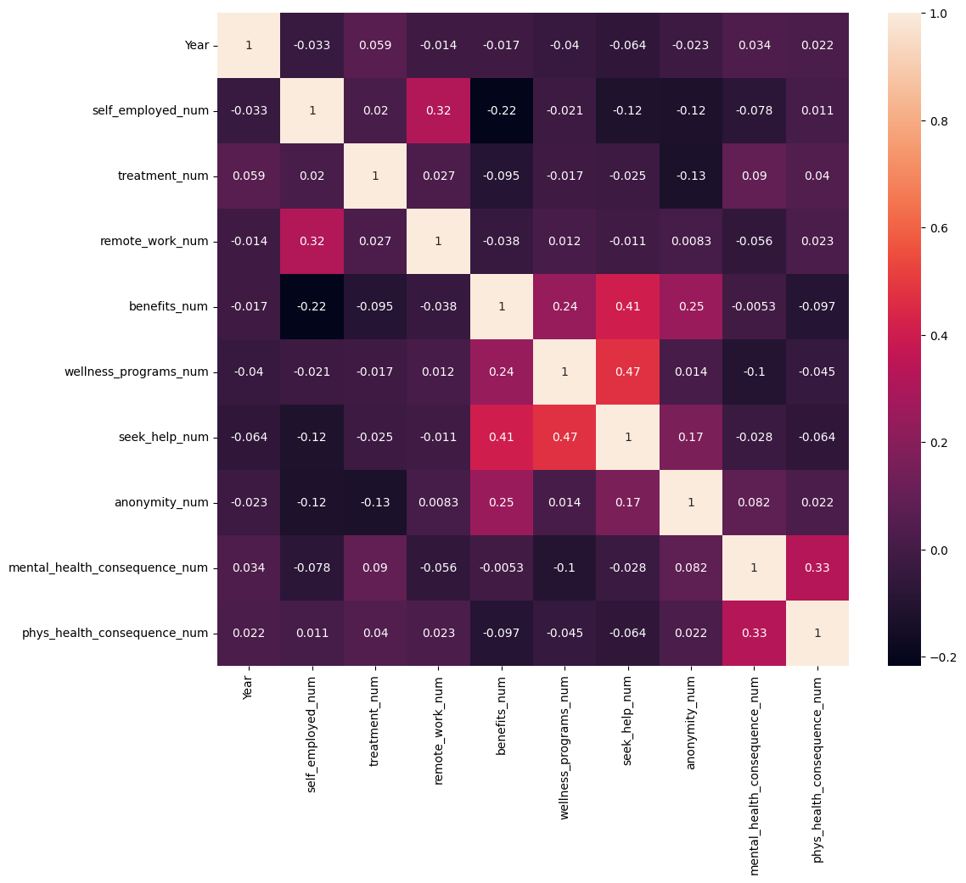

In [63]:

*# From the diagram above, the attributes that are most related are "seek_help" and "wellness_program"*

*# Followed by "seek_help" and "benefits"*

*# The following is the description of these attributes;*

1.) Wellness_program: Has your employer ever discussed mental health as part of an employee wellness program?

2.) Seek_help: Does your employer provide resources to learn more about mental health issues **and** how to seek help?

3.) Benefits: Does your employer provide mental health benefits?

Object `program` not found.

Object `benefits` not found.

## **How to Measure the Success of a Marketing Campaign**

Tracking a marketing campaign’s performance is just as important as creating its content. As marketers assess KPIs, measure relevant metrics, and analyze data, they gain a comprehensive understanding of their campaign's impact and how to optimize it for greater returns.

There are five key steps to accurately measure the success of any marketing campaign.

### Step 1: Choose an Attainable Goal

Setting a [clear and achievable goal](https://www.smartsheet.com/blog/essential-guide-writing-smart-goals) provides the foundation for the entire measurement process. Whether it's improving website traffic, generating leads, boosting sales, or promoting brand awareness, the campaign’s goal should be realistic, defined, and attainable with the resources available.

Having a specific goal in mind when measuring the campaign's performance allows marketers to understand the metrics they're tracking. Marketers should align their measurement efforts with the campaign's objectives to gain actionable insights from the evaluation process.

### Step 2: Set a Timeframe

With the campaign’s main objective set, marketers need to define when they will start — and stop — tracking and analyzing its performance. This time frame should align with the campaign’s short-term or long-term goals, as well as the team’s resources.

Setting a timeframe lets marketers capture relevant data and performance metrics that correspond to the campaign's milestones. Whether it's a time-sensitive promotion or a long-running brand-building initiative, a clear timeframe helps marketers evaluate the impact of their efforts accurately.

### Step 3: Determine Metrics

Before marketers can begin measuring campaign performance, they need to know what metrics to measure. These metrics should align with the campaign’s goal.

Here are key metrics that correspond to common campaign goals:

* **Brand Awareness Metrics:**These include reach, impressions, brand mentions, social media followers, website traffic, and search volume for brand keywords.
* **Lead Generation Metrics:**To measure the success of generating new leads, marketers can track leads captured, conversion rate, cost per lead (CPL), form submissions, and email sign-ups.
* **Sales and Revenue Metrics:** In campaigns with specific revenue goals, marketers should track sales revenue, conversion rate, return on ad spend (ROAS), and customer lifetime value (CLV).
* **Customer Engagement Metrics:** To measure engagement, marketers can track click-through rate (CTR), social media engagement, email open rate, time on page, and bounce rate.
* **Website Traffic Metrics:**Some metrics to measure traffic include Total website visits, organic traffic, referral traffic, page views, and top landing pages.
* **Content Performance Metrics:**To track how well content is resonating with customers, marketers can measure content downloads, content shares, content conversion rate, and content reach.

Once the marketing team has decided which metrics to measure, they should develop a tracking process so all team members know who will be tracking what and when. Creating a [KPI dashboard](https://www.smartsheet.com/all-about-kpi-dashboards) is an easy way for marketing teams to review and analyze their campaign’s performance metrics all in one place.

### Step 4: Create a Reporting Template

A comprehensive [reporting template](https://www.smartsheet.com/content/marketing-campaign-templates) makes it easier to analyze and present information on a campaign’s performance, and serves as a central repository for tracked data and KPIs.

A well-designed reporting template should include items like:

* Campaign goals
* Time frame
* KPI metrics measured at each stage of the campaign
* Key insights and success factors
* Challenges faced
* Actionable recommendations for future campaigns

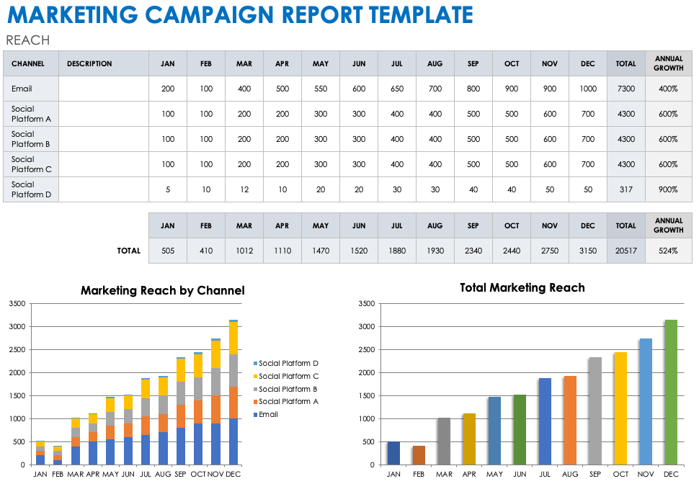

Download Marketing Campaign Report Template  
[Microsoft Excel](https://www.smartsheet.com/sites/default/files/2023-09/IC-Marketing-Campaign-Report-11843.xlsx) | [Google Sheets](https://docs.google.com/spreadsheets/d/1UkNfQnvbSKaejW96FpM1v3c5RlYpKFfOsWuGyOrS770/edit?usp=sharing)

Use this free template to organize, track, and optimize a comprehensive marketing campaign report.

### Step 5: Collect and Analyze Data

Throughout the entire campaign timeframe, marketers should collect data from various channels, such as website analytics, social media platforms, email marketing software, and advertising platforms. Their reporting template consolidates that data to organize results by KPIs and other relevant metrics.

Once they have collected the data, marketers can conduct a thorough analysis to measure the impact of a campaign's performance. Identifying trends, patterns, and correlations sheds light on what worked well and areas that need improvement. Data analysis also reveals insights on customer behavior, preferences, and engagement levels, which can guide future marketing strategies.

## **25 Metrics to Measure the Success of a Marketing Campaign**

Marketers should choose which KPIs to measure based on each campaign’s goals objectives. [Understanding the different types of marketing metrics](https://www.smartsheet.com/essential-guide-defining-business-dashboard-metrics) — from website traffic and social media engagement to lead generation and revenue growth — empowers marketers to quantify their campaign’s impact.

### 1. Return on Investment

Return on investment (ROI) is the profit achieved as a result of the money invested in a specific marketing campaign. It is an essential metric for understanding the success of any business initiative, relative to its costs.

The formula for ROI is:

Return on Investment = [(Revenue - Cost of Campaign) / Cost of Campaign] x 100

ROI is one of the most common marketing KPIs as it helps businesses make data-driven decisions about their marketing strategies. It allows them to identify which campaigns are delivering the best results, allocate resources more efficiently, and optimize future marketing efforts for greater effectiveness and business growth.

### 2. Cost-Per-Win

Cost-per-win is a metric that measures the cost-effectiveness of a marketing initiative in achieving a specific predefined goal or "win." The "win" can vary depending on the campaign's objectives, such as lead generation, website conversions, app downloads, or sales.

The formula to calculate cost-per-win is:

Cost-Per-Win = Total Cost of Campaign / Number of Conversions (Wins)

Understanding cost-per-win enables marketers to set realistic and measurable campaign objectives and allocate their campaign budget accordingly.

### 3. Cost-Per-Lead

Similar to cost-per-win, cost-per-lead (CPL) measures the cost incurred by a marketer to acquire a single qualified lead. A lead is a potential customer who demonstrates interest in a brand’s products or services and provides their contact information for follow-up.

The formula for calculating CPL is:

Cost-Per-Lead = Total Cost of Campaign / Number of Qualified Leads

Tracking and analyzing CPL allows marketers to identify the most cost-effective lead generation strategies, optimize campaigns, and allocate resources more efficiently — all ways to maximize the return on their marketing investments.

### 4. Cost-Per-Conversion

Cost-per-conversion (CPC) is the cost a marketer incurs to achieve a specific conversion goal. A conversion is an action that a marketer wants a user to take, like making a purchase, signing up for a newsletter, or downloading an app.

The formula for calculating CPC is:

Cost-Per-Conversion = Total Cost of Campaign / Number of Conversions

Tracking CPC is especially important for paid marketing campaigns, as it allows marketers to identify which campaigns, ad sets, or keywords deliver the best conversion results.

### 5. Cost-Per-Acquisition

Cost-per-acquisition (CPA) represents the average cost required to convert a prospect into a paying customer. While similar to cost-per-lead, CPA is more commonly used in e-commerce and businesses where the primary goal is driving sales rather than generating leads.

The formula for calculating CPA is:

Cost-Per-Acquisition = Total Cost of Campaign / Number of New Customers or Qualified Leads

The lower the CPA, the more cost-efficient the marketing campaign. Analyzing CPA  allows marketers to allocate their budgets more effectively, optimize their bid management strategy for any paid ads, and refine their customer acquisition strategy.

### 6. Customer Lifetime Value

Customer lifetime value (CLV), or lifetime customer value (LCV), represents the projected total revenue a customer will generate throughout their entire relationship with the brand. CLV considers factors like repeat purchases, upsells, cross-sells, and the duration of the customer's engagement.

The formula to calculate CLV is:

Customer Lifetime Value = Average Purchase Value x Average Purchase Frequency x Customer Lifespan

* **Average Purchase Value:**The average amount of money a customer spends on each purchase.
* **Average Purchase Frequency:**The average number of purchases a customer makes within a specific time frame.
* **Customer Lifespan:** The expected duration of a customer's relationship with the business.

CLV helps businesses quantify the long-term value of their customers and the ROI associated with acquiring and retaining customers. By comparing CLV to customer acquisition costs (such as marketing expenses), businesses can determine if their marketing efforts are profitable. An understanding of CLV contributes to informed strategies for resource allocation and customer retention.

### 7. Conversion Rate

In marketing campaigns, the conversion rate refers to the percentage of website visitors or users who complete a desired action based on the campaign's objectives, such as filling out a form or making a purchase.

The formula to calculate conversion rate is:

Conversion Rate = (Number of Conversions / Number of Visitors) x 100

A higher conversion rate indicates that the campaign resonates with its target audience and motivates users to take the desired actions. A lower conversion rate, conversely, suggests the need for optimization or improvements in the campaign's messaging, design, or audience.

### 8. Website Traffic

Website traffic is the number of visitors who access a website within a specific period, particularly in response to business initiatives. Website traffic is a crucial metric for measuring how effective marketing campaigns are at driving users to a website.

One of the most fundamental marketing metrics, website traffic serves as the starting point for further assessment of a campaign's impact. High website traffic  indicates that the campaign successfully attracted visitors to the website, but the quality of traffic is equally important. A high volume of traffic may mean less if visitors do not engage with the website or take additional desired actions.

### 9. Traffic by Source

Traffic by source refers to the breakdown of website visitors based on the various channels or sources through which they arrived at the website.

These sources include:

* **Organic Traffic:**These visitors find the website through search engines (e.g., Google, Bing) by entering relevant keywords.
* **Referral Traffic:**These visitors come to the website through external sources, such as other websites, social media platforms, or online directories.
* **Direct Traffic:**These visitors directly type the website's URL into their browser or access the website through bookmarks.
* **Paid Traffic:**These visitors click on paid advertisements, such as pay-per-click (PPC) ads or sponsored content.
* **Social Media Traffic:**These visitors access the website through social media platforms, such as Facebook, Twitter, LinkedIn, or Instagram.
* **Email Traffic:**These visitors click links within marketing emails or newsletters sent by the business.

Analyzing traffic by source lets marketers identify which marketing channels drive the most significant number of visitors to the website.

### 10. Channel Attribution

Channel attribution is the process of identifying and assigning credit to the various touchpoints that contribute to a customer's journey. Ads, marketing campaigns, and organic sources may all be channels that lead a customer to an eventual conversion.

For example, a customer may come across a product through a social media ad, later search for it on Google, read a blog post about it, and finally make a purchase after receiving a promotional email.

The attribution models used to credit marketing channels include:

* **First click Attribution:** The first marketing channel a customer interacted with in their journey receives full credit for the conversion.
* **Last click Attribution:** The last marketing channel a customer interacted with before converting receives full credit for the conversion.
* **Linear Attribution:**All marketing channels the customer interacted with throughout their journey receive equal credit for the conversion.
* **Time Decay Attribution:**More recent marketing channels receive more credit, while earlier touchpoints receive less credit.
* **Position-Based Attribution:** The first and last marketing channels receive more credit, while intermediate touchpoints receive less credit.
* **Data-Driven Attribution:**Machine learning algorithms analyze customer data and assign credit to each marketing channel based on its actual impact on conversions.

Channel attribution helps marketers identify which channels drive the most valuable conversions and allocate their marketing budgets accordingly. This guide will dive deeper into the different attribution models below.

### 11. Sessions

A session is a metric for measuring a user’s interactions with a website or digital platform. A session begins when a user initiates their visit to the website or app and ends after a set period of inactivity.

Each time a user accesses a website or app, it counts as one session, regardless of the number of pages viewed or actions taken during that visit.

Marketers use session data to analyze user behavior, track trends in website traffic, and identify patterns in user engagement. For example, a high number of sessions generally indicates a popular website with substantial user engagement. Session data helps marketers segment users based on their behavior, interests, and engagement level.

### 12. Session Duration

Session duration refers to the length of time a user spends on a website or digital platform during a single session. This measurement provides crucial insight on user engagement and the level of interest in a website’s content or offerings.

Marketers use session duration data to analyze content performance and user experience. Longer session durations generally indicate higher user engagement, suggesting that users find value in the content and spend more time exploring the website's offerings. Shorter session durations might mean that users are not finding what they are looking for or that the content is not compelling enough to hold their attention.

### 13. Returning Visitors

Returning visitors are individuals who have had at least one previous session on the website or app before their current visit. These users can provide valuable insight into the effectiveness of a website’s content, user experience, and marketing efforts.

Measuring returning visitors can help marketers gain insight on::

* **Engagement and Loyalty:**Returning visitors indicate a higher level of interest in the website's content or offerings. They are more likely to be repeat customers or loyal followers of the brand.
* **User Retention:**Higher numbers of returning visitors suggest that the website is successful in retaining its audience.
* **Content Relevance:** Returning visitors demonstrate that the website's content is relevant to the target audience. It shows that users find value in the information, products, or services offered.
* **Conversion Potential:**Returning visitors have already shown interest in the website, making them more likely to convert, whether through purchases, form submissions, or other desired actions.
* **Marketing Effectiveness:**By analyzing the behavior of returning visitors, marketers can evaluate the impact of their marketing campaigns and strategies on user retention and repeat visits.

A healthy balance between new and returning visitors indicates a well-rounded and successful marketing strategy.

### 14. Bounce Rate

Bounce rate measures how often a user lands on a page and then exits the website without clicking any links or engaging with the content. The ideal bounce rate may vary depending on a website’s or campaign's objectives.

If a webpage’s goal is to provide quick information or encourage immediate actions, a high bounce rate may be acceptable . In most cases, however, lower bounce rates are preferred, as they indicate higher engagement and a deeper exploration of the website's content.

Bounce rates are a key metric for analyzing landing page performance and specific campaign elements. They provide valuable insight on content relevance, ad performance, user experience, and conversion optimization.

### 15. Exit Rate

Exit rate is the percentage of visitors who leave a website or digital platform from a specific page. While bounce rate measures single-page sessions, exit rate focuses on the last page a user visits before leaving the website.

The formula to calculate exit rate is:

Exit Rate = (Number of Exits from the Page / Total Number of Page Views) x 100

Exit rates are a valuable marketing metric for understanding user behavior. High exit rates on specific pages may indicate issues with the content, design, or user experience. Marketers can analyze these pages to identify areas for improvement and optimize them to reduce exit rates.

### 16. Page Views

Page views refer to the number of times a specific web page or digital content is viewed by users. Each time a user accesses a page, it counts as one page view.

Marketers use page view data to understand which pages attract the most visitors. With that information, they can identify successful content and optimize user experience. Analyzing page views helps marketers make informed decisions to improve website performance, enhance user engagement, and drive the success of their marketing campaigns.

### 17. On-Page Time

On-page time refers to the duration of a user’s active engagement with a specific web page in a single session. On-page time is measured from the moment a user accesses a page until they leave it or become inactive.

On-page time indicates the level of interest a user has in a website’s content and the extent to which the content captures their attention.

### 18. Impressions

Impressions are the number of times an advertisement or piece of content is shown to the target audience. They represent the potential visibility of the content, regardless of whether users interact with it.

Impressions shed light on the initial impact of a campaign, as well as the potential audience size for its content. Marketers use this information to monitor brand visibility, ad performance, and ad frequency.

Impressions count each time an ad is served, not whether the user actively viewed or engaged with it. While impressions provide insight into reach, other metrics like click-through rates and conversions are used to measure the actual engagement and effectiveness of the campaign.

### 19. Backlinks

Backlinks are incoming hyperlinks from one website to another. They serve as a crucial factor in search engine optimization (SEO) and measuring digital marketing campaign effectiveness.

An effective link-building marketing strategy can impact:

* **SEO Ranking:**In search engine algorithms, backlinks indicate a website’s credibility and relevance. Websites with a higher number of quality backlinks are often ranked higher in search results, leading to increased organic traffic and visibility.
* **Referral Traffic:**Backlinks lead to direct referral traffic from external websites to the brand’s landing page. When reputable sites include links to another company’s content, they introduce the brand to new audiences.
* **Content Engagement:**The number of backlinks to specific content indicates how engaging and valuable that content is to others. The more backlinks a particular piece of content receives, the greater its resonance with the target audience.
* **Brand Authority:**Backlinks from authoritative websites enhance a brand's reputation and authority in its industry or niche. These signals of trustworthiness positively impact user perception and influence their decision-making process.

Not all backlinks are created equal. Quality backlinks from reputable and relevant websites hold more weight in SEO and campaign effectiveness than low-quality or spammy backlinks. While tracking backlinks is essential for measuring marketing campaign effectiveness, marketers should focus on obtaining high-quality backlinks from authoritative sources.

### 20. Social Reach

Social reach measures the total number of unique users exposed to a brand's content through social media channels during a specific period. Including organic and paid traffic, social reach represents the size of a marketing campaign’s audience on social platforms.

A higher social reach indicates that the campaign is resonating with a broader audience and gaining traction among users. Evaluating this metric helps marketers assess the campaign's ability to reach its intended target audience and increase brand visibility.

Additionally, social reach sheds light on the effectiveness of the campaign's content and messaging. Highly shareable and engaging content is more likely to reach a larger audience through user interactions.

### 21. Social Engagement

Social engagement refers to the level of interaction, involvement, and participation that users have with a brand's content or messages on social media platforms.

Common social engagement actions include:

* Likes
* Comments
* Shares
* Retweets
* Mentions
* Clicks

High social engagement indicates that the campaign is resonating with the target audience and generating excitement around the brand and its offerings. Monitoring social engagement metrics enables marketers to evaluate the success of their content strategy, identify which types of content resonate most, and adapt their approach to create higher impact campaigns.

### 22. Return on Ad Spend

Return on ad spend (ROAS) is a metric used to measure the revenue generated from a specific advertising campaign relative to the amount spent on that campaign. ROAS helps advertisers understand the effectiveness and profitability of their efforts.

The formula to calculate ROAS is:

Return on Ad Spend = Revenue Generated from Ad Campaign / Ad Spend

An ROAS greater than 1 shows that the campaign generated more revenue than the ad spend, signifying a positive ROI. By comparing the ROAS of different campaigns, marketers can allocate their ad budgets more effectively, invest more in high-performing campaigns, and adjust or discontinue low-performing ones.

### 23. Email Open Rate

Email open rate is the percentage of recipients who open an email out of the total number of emails delivered in a campaign. It provides insights into the effectiveness of the email's subject line, sender name, and target audience.

A high open rate suggests the subject and sender are relevant and engaging to the email’s recipients. Tracking email open rate allows marketers to identify which emails are performing well and which ones may need optimization, leading to better engagement and conversions.

### 24. Click-Through Rate

Click-through rate (CTR) measures the percentage of users who clicked a specific link or call-to-action, out of the total number of users who viewed the campaign content. CTR is an important metric in digital advertising, email marketing, and online campaigns.

A higher CTR indicates that a larger proportion of the audience found the content compelling enough to take the desired action, such as clicking a link to learn more or make a purchase. This metric is essential for measuring marketing campaign effectiveness because it directly correlates to user engagement and actions.

### 25. Cost-Per-Click

Cost-per-click (CPC) is a digital advertising metric that measures the cost incurred by the advertiser for each click on their ad. CPC is commonly used in pay-per-click (PPC) advertising models, where advertisers only pay when someone clicks on their ad.

The formula to calculate CPC is:

Cost-Per-Click = Total Cost of Ad Campaign / Total Number of Clicks

Tracking CPC helps marketers determine how efficiently they are driving user engagement and website traffic. A lower CPC can lead to increased traffic and conversions while optimizing the budget.

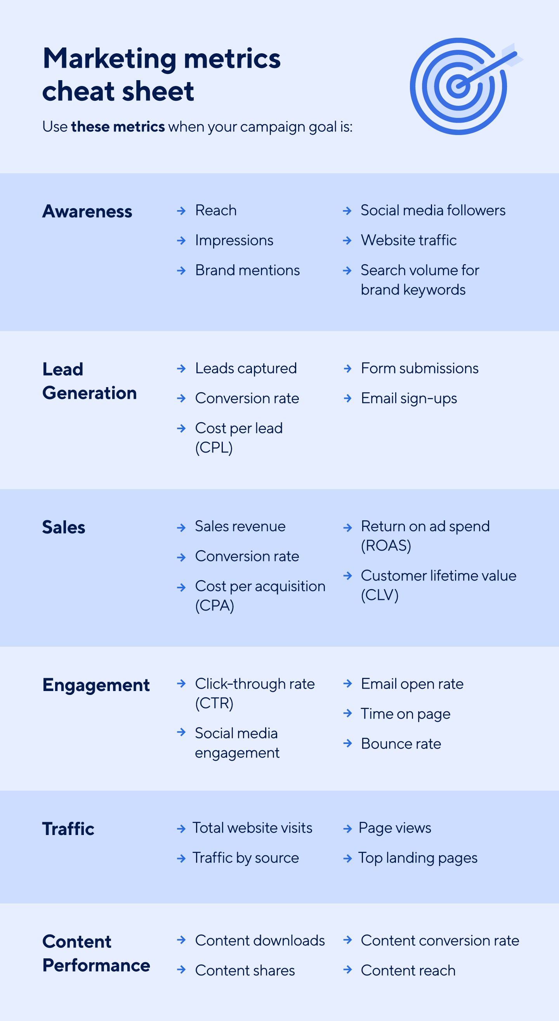

## **Digital Marketing Attribution Models for Campaigns**

Digital marketing attribution models play a pivotal role in understanding the contribution of each marketing touchpoint in a customer's journey. These models assign credit to various channels and interactions so that marketers can analyze their impact.

Digital marketing attribution models help marketers:

* Measure campaign effectiveness
* Allocate resources wisely
* Improve the customer experience
* Identify key touchpoints that influence conversions
* Collaborate and align with different marketing teams and channels
* Optimize their digital marketing strategy

Businesses that understand the different attribution models — including first-touch, last-touch, and multi-touch models — gain priceless insights into which marketing efforts drive conversions and impact their bottom line.

### First-Touch Attribution Model

The first-touch attribution model assigns 100% of the credit for a conversion to the first marketing touchpoint a customer interacts with during their journey. It emphasizes the initial point of contact, such as clicking a social media ad.

The first-touch model is simple and straightforward, making it easy to implement and interpret. It’s most valuable in scenarios where the initial touchpoint has a significant impact on the customer's decision-making process.

The first-touch model is particularly useful for:

* **Brand Awareness Campaigns:**When the primary objective is to introduce a brand or product to a new audience, the first-touch model provides insights into the effectiveness of awareness-building efforts.
* **Lead Generation:**In lead generation campaigns, the first interaction often plays a crucial role in capturing a prospective customer’s interest and initiating the sales funnel.
* **New Product Launch:** When launching new products or services, understanding the first touchpoint helps marketers identify which channels drive early interest and engagement.
* **Event Registrations:**When measuring event registrations, the first-touch model can shed light on the marketing efforts that initially attracted attendees.
* **One-Touch Conversions:** In cases where conversions mainly occur after a single interaction, such as impulse purchases or quick sign-ups, the first-touch model provides relevant attribution data.

### Last-Touch Attribution Model

The last-touch attribution model assigns 100% of the credit for a conversion or sale to the final marketing touchpoint that occurs before the customer takes the desired action. It focuses solely on the last interaction in the customer journey.

This attribution model should be applied to campaigns where the final touchpoint ultimately influences the customer’s decision-making process and drives conversion.

The last-touch attribution model can be used for:

* **Direct Response Campaigns:**For campaigns with a clear call-to-action, such as "Buy Now" or "Sign Up," the last-touch model attributes conversions directly to the final interaction that prompts the action.
* **E-commerce Sales:**In e-commerce, where the customer journey often culminates in a purchase, the last-touch model provides insights into the marketing channel or campaign that leads to sales.
* **Limited Interaction Journeys:** When the customer journey involves minimal touchpoints before conversion, the last-touch model accurately attributes the credit to the final interaction.
* **Short Sales Cycles:**In cases where the sales cycle is brief and customers make quick decisions, the last-touch model provides relevant and actionable attribution data.
* **Promotional Campaigns:** For time-sensitive promotions or flash sales, the last-touch model helps identify the specific marketing effort that drove immediate results.

### Linear Attribution Model

The linear attribution model distributes equal credit to each marketing touchpoint or interaction that occurs throughout the customer journey. It acknowledges that every touchpoint is important in influencing the customer's decision-making process.

The linear attribution model works best in scenarios where multiple touchpoints play a significant role in driving customer conversions, and where marketers want to recognize the collective impact of each interaction.

This model is particularly effective for:

* **Complex Sales Cycles:** In B2B or high-involvement purchases where the customer journey involves multiple interactions across various channels, the linear model provides a fair representation of each touchpoint's contribution.
* **Longer Sales Funnels:** The linear model helps assess the cumulative effect of marketing efforts when the sales funnel is extended, and when multiple channels nurture leads over an extended period.
* **Multi-Channel Campaigns:**For campaigns that leverage multiple marketing channels and platforms, the linear attribution model considers the contribution of each channel in engaging and converting customers.
* **Lead Nurturing Campaigns:**The linear model attributes value to all touchpoints that contributed to lead progression in campaigns focused on nurturing leads over time.
* **Content Marketing:** For content-driven marketing strategies, where potential customers interact with multiple pieces of content before conversion, the linear attribution model recognizes each content asset’s role in the customer's journey.

### Time Decay Attribution Model

The time decay attribution model gives more credit to the marketing touchpoints that occur closer to the conversion event. As the customer journey progresses, the influence of each touchpoint increases — and the impact of the previous interaction decays by comparison.

Marketers use the time decay attribution model when the customer journey is relatively long and involves multiple touchpoints, but the most recent interactions hold the most significance.

The time decay attribution model is most useful in these scenarios:

* **Long Sales Cycles:** For products or services that require extensive research and consideration, the time decay model appropriately attributes more value to the touchpoints that occur closer to the purchase decision.
* **Content Marketing Funnel:**In content-focused marketing campaigns, the time decay model acknowledges the value of content pieces that engage customers in the later stages of the funnel, driving them towards conversion.
* **Multi-Step Conversions:**When a conversion involves multiple steps, such as filling out a form and then making a purchase, the time decay model recognizes the importance of the touchpoints leading up to the final conversion step.
* **Continuous Engagement Campaigns:**In campaigns where continuous engagement and nurturing are critical, the time decay model rewards the touchpoints that maintain customer interest and interaction over time.
* **Product Upsells and Cross-Sells:**When customers are already familiar with a brand and additional marketing efforts aim to upsell or cross-sell, the time decay model gives credit to the recent interactions that drive those additional purchases.

### U-Shaped Multi-Touch Attribution Model

The U-shaped multi-touch attribution model, also known as the U-curve or position-based model, distributes credit to multiple touchpoints along the customer journey but gives a larger share of the credit to the first and last touchpoints.

This attribution model strikes a balance between the first-touch and last-touch models, recognizing the importance of both the initial engagement and the final action in the conversion process. The U-shaped multi-touch attribution model can be applied to marketing efforts where both the first interaction and the last interaction significantly influence the customer's decision.

These scenarios include:

* **Considered Purchases:**For products or services that require careful consideration and research, the U-shaped model appropriately attributes credit to the touchpoints that create awareness and those that lead to the final conversion.
* **Lead Generation with Follow-Up:** In campaigns involving lead generation and nurturing, the U-shaped model recognizes the value of both the initial lead capture and the subsequent interactions that lead to the conversion.
* **Multi-Channel Campaigns:**When marketing efforts span multiple channels and platforms, the U-shaped model accounts for each channel’s contribution to the customer's journey, from initial awareness to the final conversion.
* **B2B Sales:**In B2B sales cycles that involve multiple interactions and stakeholders, the U-shaped model provides insights into the various touchpoints that influence decision-making.
* **High-Value Conversions:**When the value of the conversion is significant, the U-shaped model attributes credit to both the touchpoints that attracted the prospect and those that sealed the deal.

### W-Shaped Multi-Touch Attribution Model

The W-shaped multi-touch attribution model, also known as the W-curve or time-decay model with emphasis, gives credit to three critical touchpoints in the customer journey: the first touch, the touchpoint closest to the conversion, and the last touch.

A variation of the time decay model, this model places more emphasis on recent interactions that drive conversion, while still recognizing the importance of the first touch on customer awareness.

The W-shaped multi-touch attribution model may be applied in more complex customer journeys.

Some examples are:

* **Multi-Step Conversions:** When a conversion involves multiple stages — such as signing up for a trial, attending a webinar, and then making a purchase — the W-shaped model recognizes the importance of each critical touchpoint in the conversion process.
* **Lead Nurturing with Conversion Funnels:**In lead nurturing campaigns with defined conversion funnels, the W-shaped model attributes credit to the initial lead capture, the touchpoint leading to the conversion, and the final conversion interaction.
* **Multi-Channel Campaigns with Closing Touch:**When marketing campaigns span multiple platforms and the final touchpoint significantly influences conversion, the W-shaped model gives due credit to each channel.
* **Considered Purchases with Critical Steps:** The W-shaped model identifies crucial touchpoints for considered purchases, where certain interactions guide customers towards the final conversion.
* **Highly Competitive Markets:**In competitive markets, where multiple touchpoints are required to stand out, the W-shaped model acknowledges the importance of initial engagement, critical intermediate touchpoints, and the final persuasive interaction.

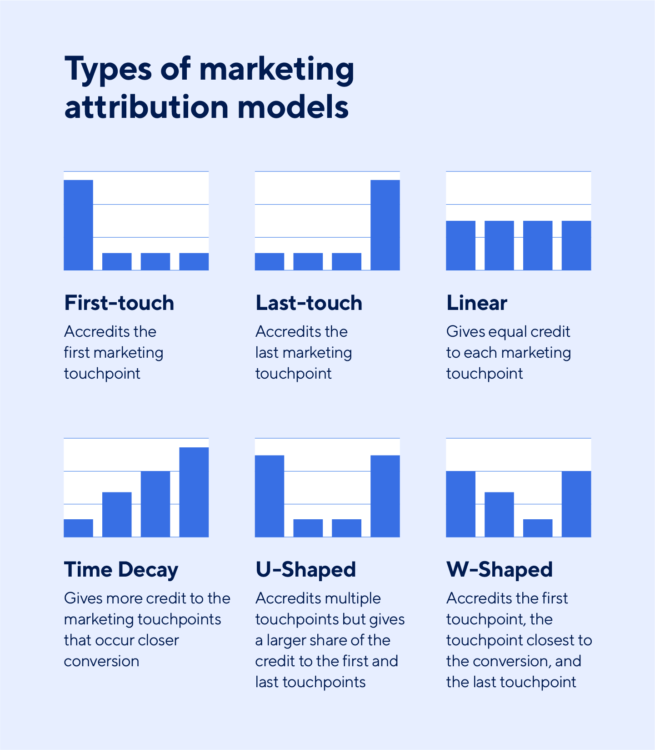

## **8 Tips for Measuring the Success of Marketing Campaigns and How to Optimize Them**

A thorough marketing campaign tracking strategy is an essential part of any successful campaign — as important as planning and executing its content. These best practices empower marketers to effectively measure each campaign’s impact and understand how to optimize their strategies.

1. **Set Clear Goals:**Campaign ideation and content creation must align with overarching goals. To begin a successful campaign, marketers must clearly define their objectives and the timeframe for achieving them, using OKRs (objectives and key results) on a monthly, quarterly, or yearly basis. This approach will help maintain campaign momentum and track its progress.
2. **Include Specific KPIs:**Comprehensive details about the campaign’s KPIs help the entire marketing team understand the steps they need to take to achieve their goals. Instead of a general KPI like “Increase website traffic,” a more specific and detailed objective might be, “Increase organic website traffic by 20% and referral traffic by 15% within the next six months.” This specific KPI outlines the focus areas and growth targets for different traffic sources, allowing teams to align their strategies accordingly.
3. **Set Up Tracking Tools Before Launching a Campaign:**Without advance preparation and testing, marketers may not be able to track the metrics they need to understand their campaign’s impact. It’s important to set up and test tracking tools before launching any campaign.
4. **Try A/B Testing:**Slow and steady A/B testing in the beginning of a campaign can help marketers understand what they need to succeed. Testing and tracking different variations of ad creative, copy, or even target audiences can reveal a more effective marketing formula.
5. **Consider Outside Influences:**Marketing metrics may vary due to outside factors that aren’t related to a campaign, such as a major product announcement or PR push. It’s important to consider these outliers when interpreting  data to optimize a campaign. If there are any unusual numbers, marketers should consider the full picture before making conclusions about their campaign.
6. **Be Patient:**Success takes time, especially when it comes to marketing. It could take weeks or even months to see the results of a campaign. If metrics appear to be stagnant for an extended period after launch, the campaign may just be building momentum before taking off.
7. **Create a Marketing Measurement Template:**Once marketers have determined the best metrics to track their campaign’s goals, they should create a comprehensive template that includes all the KPIs they plan to track and assess. Smartsheet’s [marketing campaign management template set](https://www.smartsheet.com/marketplace/us/template-sets/marketing-campaign-management) enables seamless campaign measurement by managing, tracking, and visualizing marketing campaign data all in one place.
8. **Build a Retargeting Campaign:**People often need more than one marketing touchpoint to sway their decision. A retargeting ad campaign aims to reach users who have previously visited a website or engaged with specific content. They’re highly effective at pushing these “warm” leads further down the marketing funnel, maximizing the chances of converting them into loyal customers and achieving higher return on ad spend.

## **Trends in Marketing Campaign Measurement**

With technology advancing and more information available than ever before, consumers expect the companies they interact with to adapt. Marketers must stay nimble and up-to-date on the latest marketing tracking tools and trends.

Here are some key developments to follow:

### Artificial Intelligence

Artificial Intelligence (AI) and its subdisciplines, like machine learning and natural language processing, are already revolutionizing marketing research and analytics. As businesses strive for data-driven decision-making and performance optimization, these technologies can also simplify marketing measurement and attribution processes.

AI-driven marketing pipelines deliver real-time insights to:

* Identify patterns
* Forecast trends
* Improve targeting
* Enable advanced data processing

Before AI, it could take months to collect relevant data from A/B testing. The advancements in AI-driven measurement and attribution will undoubtedly empower marketers to optimize their strategies with greater speed and precision.

### Automation

Automation uses software to provide a more personalized experience for customers and leads, making monotonous marketing work faster and easier. Marketing automation has the potential to keep campaigns running smoothly and efficiently, so marketers can focus on creative strategies.

Automation can be used to:

* Personalize content
* Schedule and execute consistent updates
* Track and visualize data
* Prioritize tasks as needed
* Streamline processes across different workflows and marketing channels

With marketing automation, marketers are finding new, effective ways to create a unified customer experience that keeps users engaged throughout the sales funnel.

### Cross-Device Marketing

As more consumers search the web from the convenience of their smartphones, cross-device marketing has become an important tool. Cross-device marketing identifies customers across different devices and delivers content that seamlessly adapts to their web access methods.

From cross-device marketing comes cross-device measurement, which gives marketers insight into a customer’s journey across multiple devices. Cross-device measurement has raised concerns about users’ privacy rights, but — with the help of AI — marketers are developing innovative strategies to consolidate fragmented device data for streamlined analytics.

Empower your people to go above and beyond with a flexible platform designed to match the needs of your team — and adapt as those needs change.

The Smartsheet platform makes it easy to plan, capture, manage, and report on work from anywhere, helping your team be more effective and get more done. Report on key metrics and get real-time visibility into work as it happens with roll-up reports, dashboards, and automated workflows built to keep your team connected and informed.

When teams have clarity into the work getting done, there’s no telling how much more they can accomplish in the same amount of time. [Try Smartsheet for free, today.](https://www.smartsheet.com/try-it?lpv=botlink&trp=11842)

***Conclusion:***

Thus,by implementing these ideas and solutions,the project can work towards the public health awareness and promoting environmental sustainability